**Apache Tomcat**:

* we can manually start the service by **configure tomcat,** and then clicking start. The default port is 8080.
* In IntelliJ there is some steps needs to be taken
  + **Tomcat and TomEE plugin** must be enabled.
  + Then go to **run -> edit configuration -> click on + -> select tomcat server -> local**
  + If there is warning for no artifact in deployment, we can add an artifact. For debugging purpose use **Web application: exploded**

**# NEED TO LEARN MORE BEFORE I UNDERSTAND THE PROJECT CREATING IN SPRING. FOR NOW JUST HAVE TO TRY TO JUST TRY OUT DIFFERENT THINGS AND SEE.**

**Spring MVC:**

* **Dispatcher** is the already developed, it works as a front controller.
* **Init-param** is the configuration for our configuration.xml file.

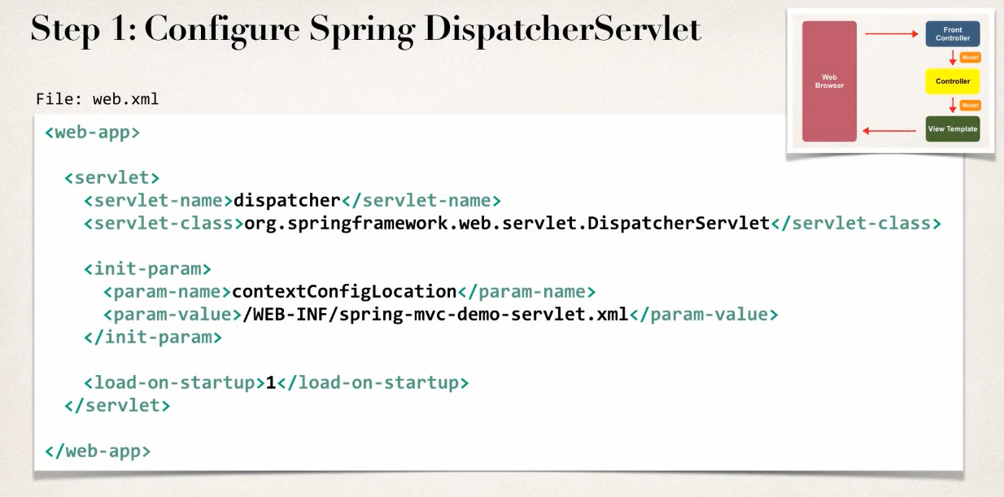

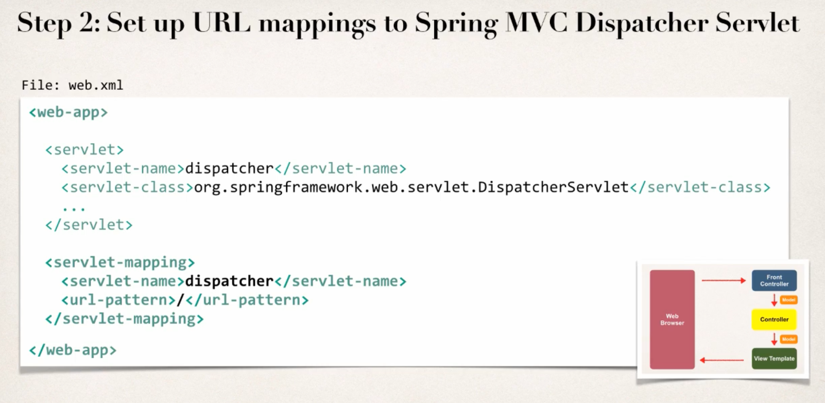

* Here we basically define for any URL pattern request, we pass it to dispatcher service.
* We can define our URL patter different according our needs.
* Important: servlet-name here must match the servlet-name at the start where we defined dispatcher (at step-1)

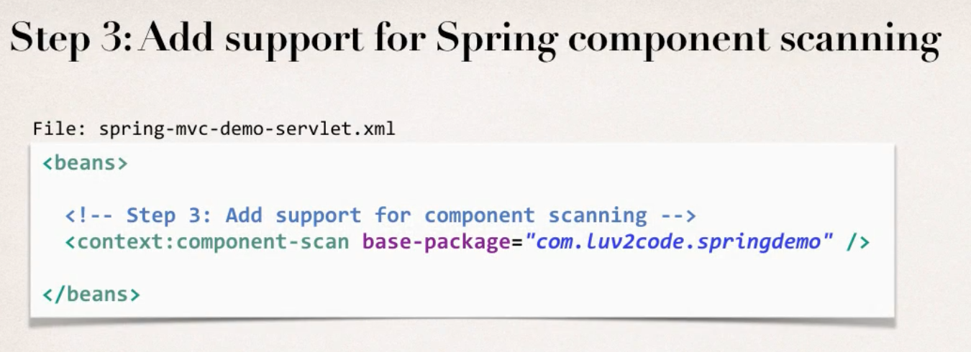

* This configuration goes to the xml file, that we defined in the step 1.

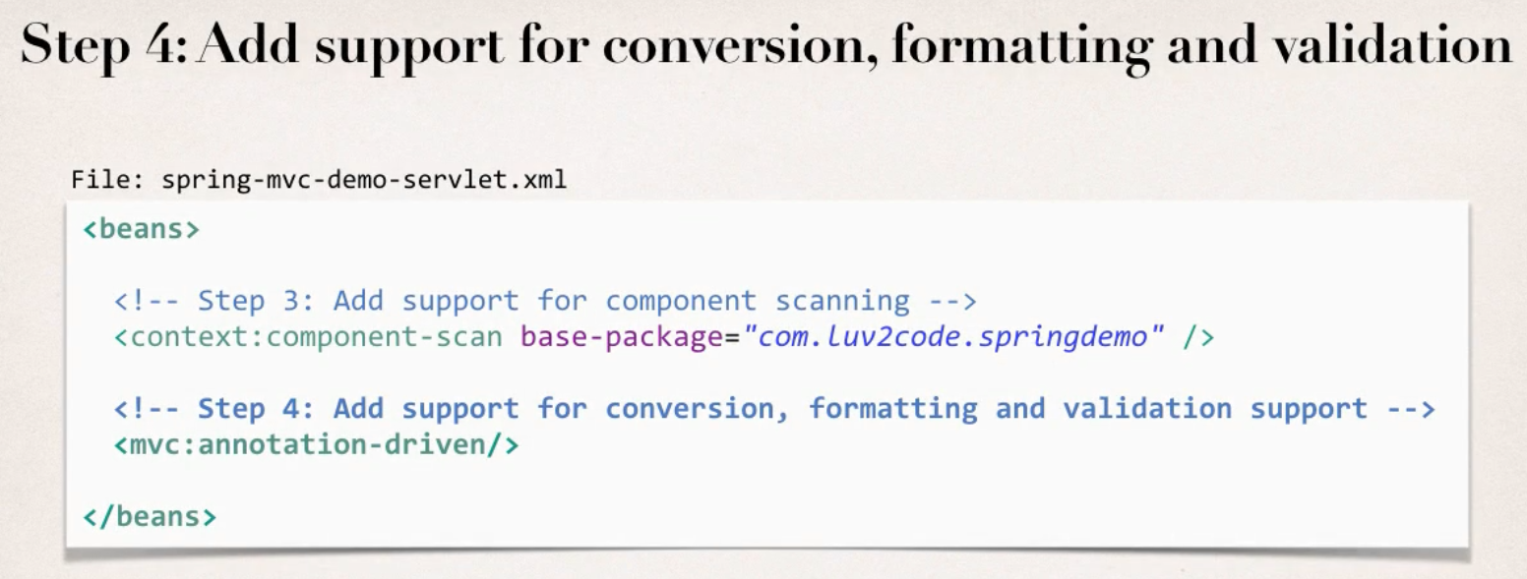

* This supports conversion of form-data, formatting form-data, form-validation etc.

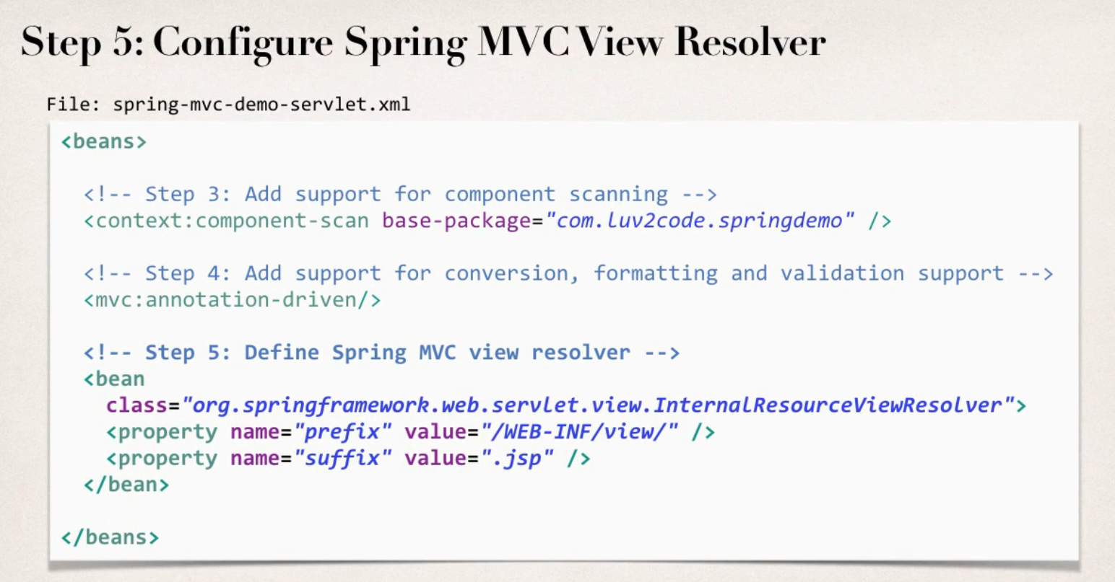

* This configures where are the pages located. The prefix and suffix basically just the path and extension when we write a view name in our code.

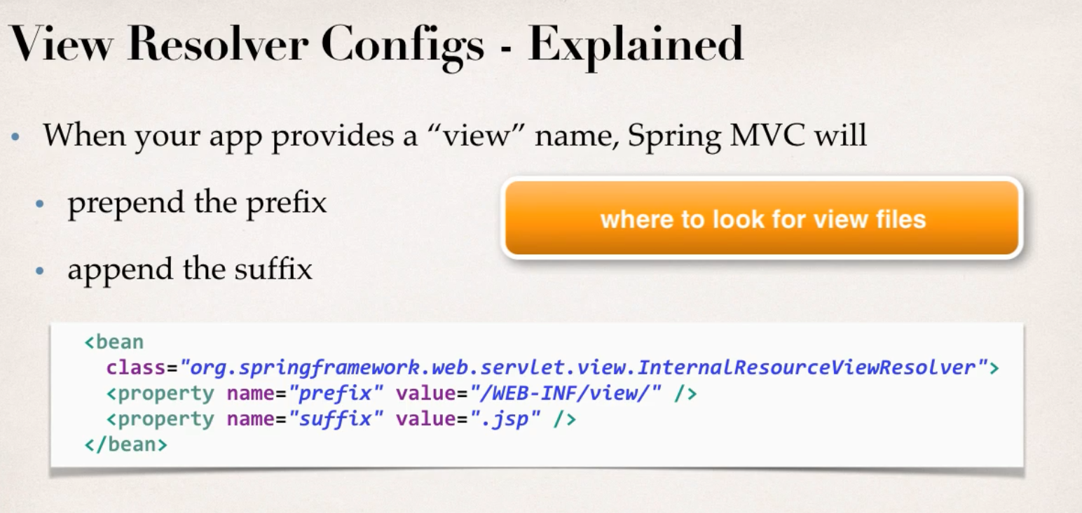

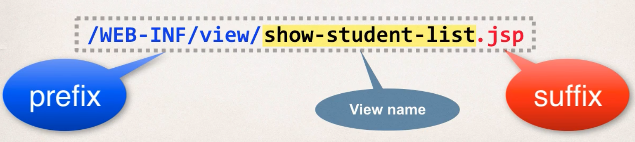

**Java Config:** This process is without xml files, which replaces the xml files.

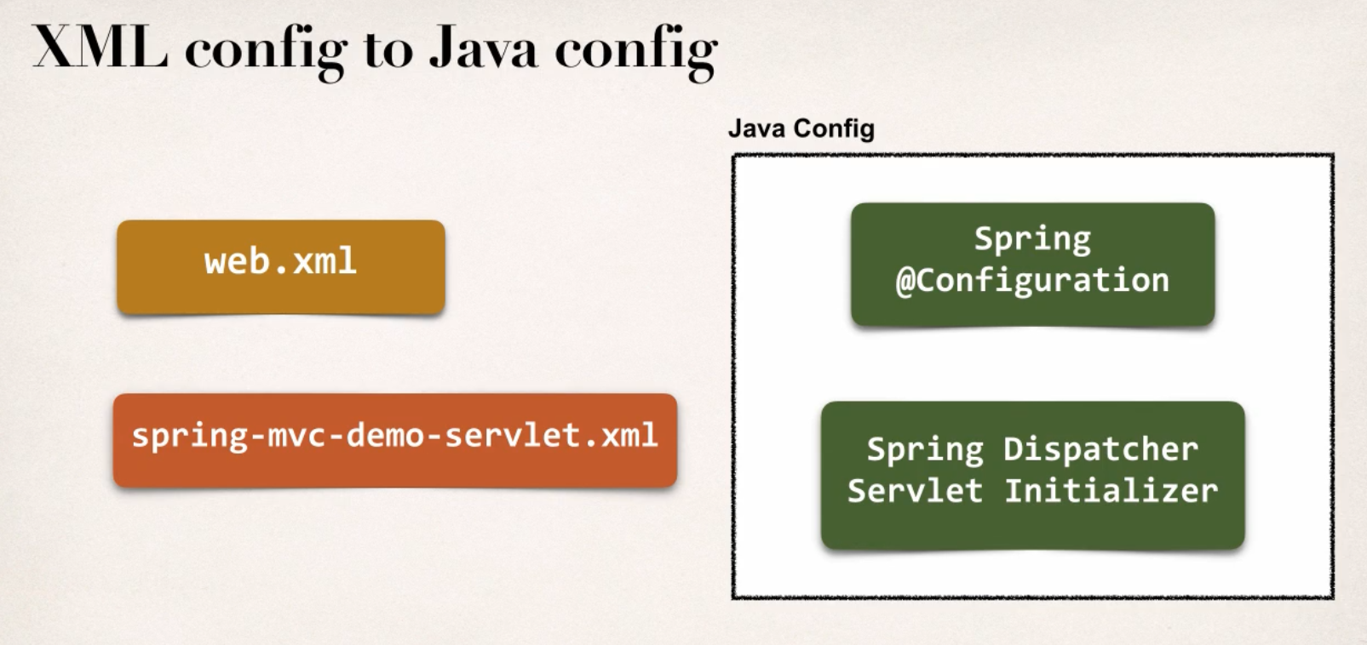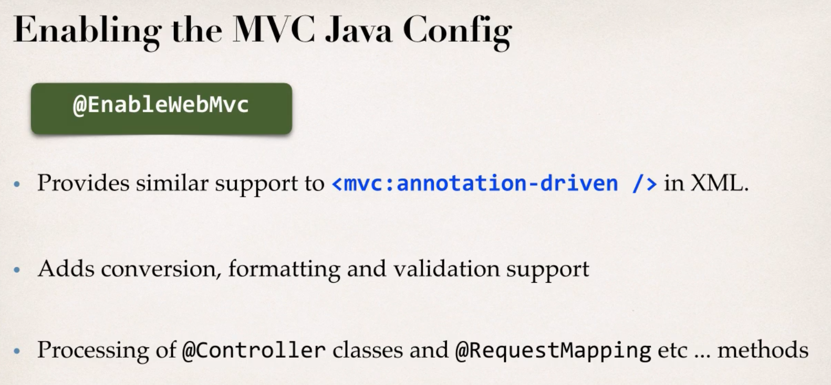

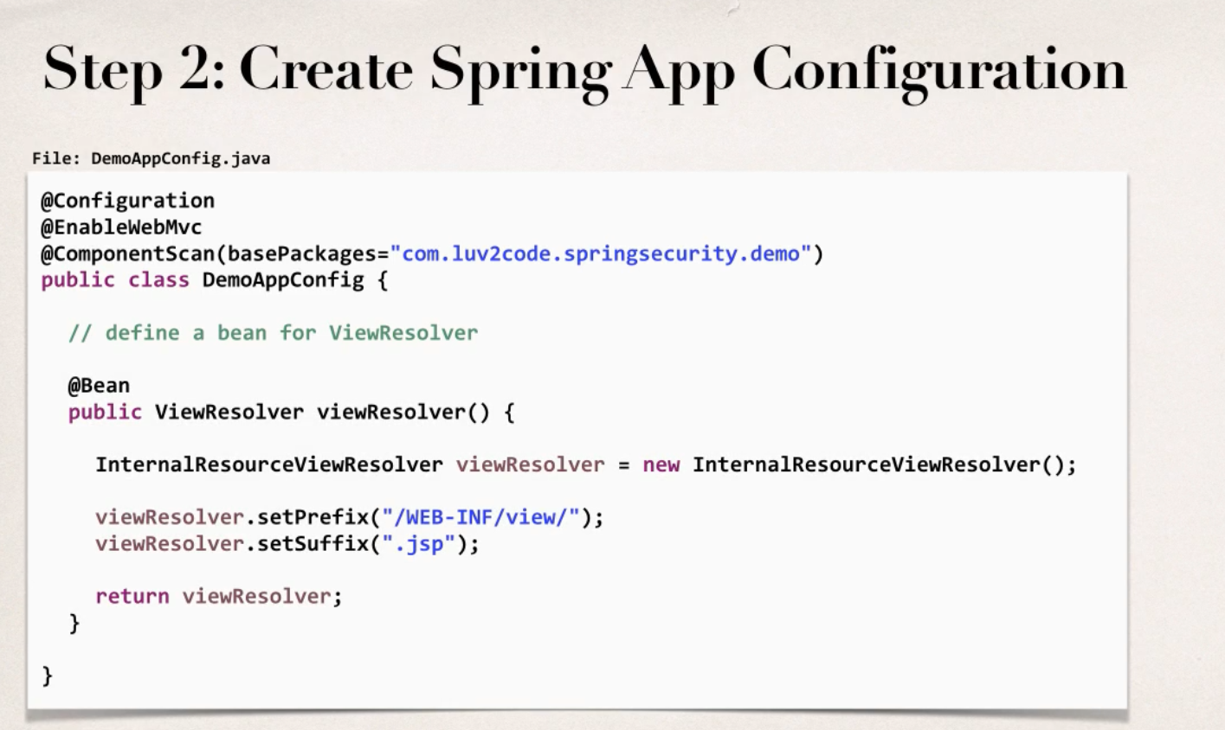

This step makes this class a configuration class, with mvc support enabled and component scan enable as well.

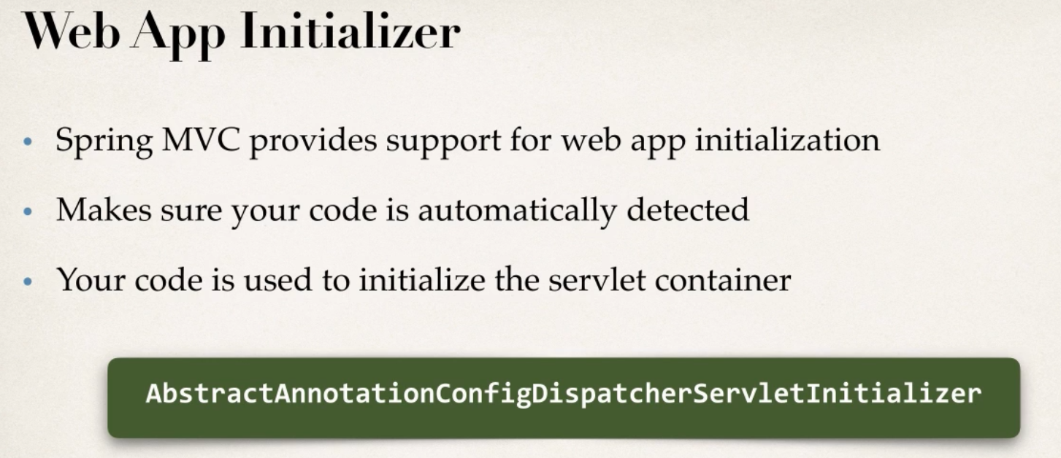

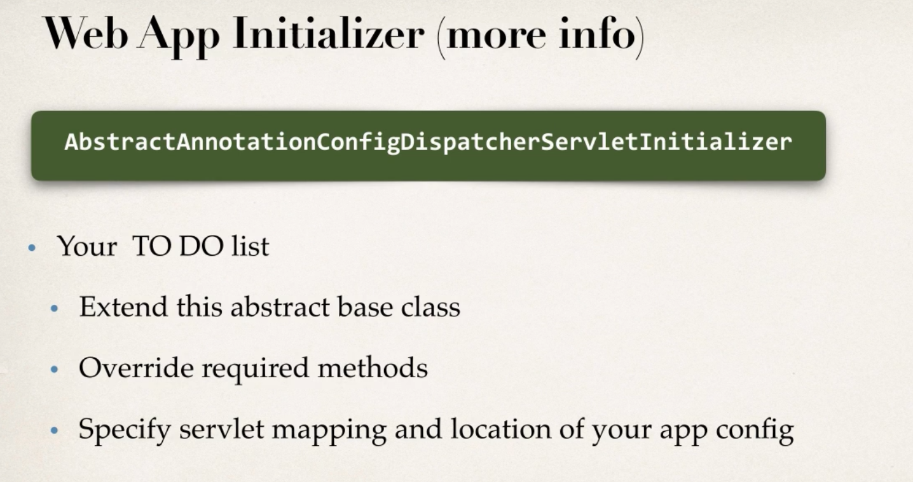

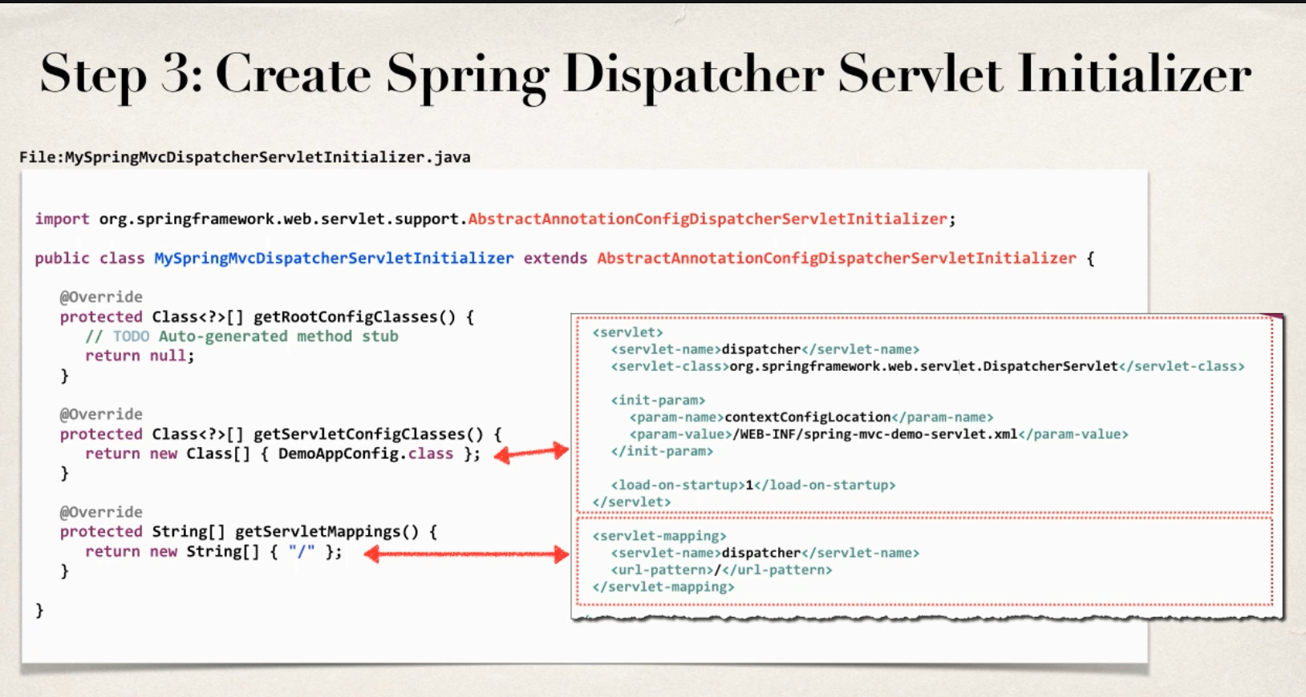

After this we can use controller, model, view etc.